Mechanical Properties of Brass and Aluminum: Tensile, Shear, and Hardness Testing

Authors: Janis Corona, Henry Glover, Oliver Palafox, Naya Williams
Abstract
Three set of experiments were conducted for a proper evaluation of the material properties for Aluminum 2024-T3 and Brass 360 through tensile, shear, and Vickers Hardness tests. Testing for different material properties for both metal samples revealed the material's mechanical performance capabilities through values of elastic modulus, tensile, shear, and hardness strength. Based on the calculated results, aluminum indicated a higher yield and ultimate strength compared to brass, which means it can withstand more deformation. Meanwhile, the Vickers hardness test results suggest that brass has material properties that indicate higher durability due to its higher hardness and yield strength. Although the results of both indicate different behaviors in material properties, tensile testing allows insight into ductility/ or brittleness, whereas the Vickers hardness test determines the resistance to permanent deformation.

- Introduction
These series of experiments, conducted with meticulous attention to detail, aims to observe and differentiate the material properties of Brass 360 and Aluminum 2024-T3 using tensile, shear, and hardness testing. These mechanical tests, widely used in industry, are crucial in determining the suitability of a material for its intended purpose. By employing the computational methods of Eq. 1-10, we can thoroughly evaluate each material's properties, thereby revealing its strengths and weaknesses in terms of mechanical performance.
1.1 Tensile Test
Tensile testing is a destructive test in which the sample endures a continuously increasing uniaxial load until failure is reached [1]. As the testing sample undergoes tensile stress, the strain on the sample can be determined using the position of a point on the loading apparatus. The deformation of the tensile testing is seen at the middle section of dog-bone sample which experiences elongation in length L and a decrease in diameter d.
To represent a full stress-strain curve, tensile strength was solved by converting the load data given by the application to calculate stress using the following formula:

$$σ=\frac{F}{A}$$ | (1)

where F was the force data in Newtons and A was the average cross-sectional area of the dog-bone. The results were converted to MPa with multiplication (10⁻⁶). Engineering strain was then calculated using an initial gauge length of 35mm. The formula is shown below:
$$ϵ= \frac{∆L}{L_{0}}$$ | (2)
where ΔL is the change in length in (m) and L₀ is the initial gauge length. The stress strain curve was then plotted. Young’s modulus was equated using the slope of the elastic region and converted from MPa to GPa. The governing equation is as follows:
$$E= \frac{σ}{ϵ}$$ | (3)
Where σ is the engineering stress (per unit area) and ϵ is the engineering strain (dimensionless). To determine the 0.2 % offset yield strength Hooke’s law is employed:
$$σ=E∙ϵ$$ | (4)
where E is Young’s modulus and ϵ is the engineering strain. The 0.2 offset yield strength is the stress at which permeant deformation begins, the material no longer behaves elastically. The ultimate tensile strength is the max stress before failure and is calculated using the MAX function in Excel. Ductility is a measure of strain converted into a percent elongation. This is solved using the following formula:
$$ϵ_{f}=ϵ_{f, TOT}-\frac{σ_{f}}{E}$$ | (5)
where $ϵ_{f, TOT}$ is the last positive value in the strain column and $σ_{f}$ is the stress at fracture (i.e. the last positive value in the stress column). $ϵ_{f}$ is then multiplied by 100 to get %Elongation. Work of fracture is calculated using the equation employed below:
$$(A2-A1)∙\frac{(B1+B2)}{2}$$ | (6)

where A is the strain data and B is the stress data. Calculate the sum of all the data values to find the work of fracture (MJ/m³). Similar to tensile strength, shear strength is found by converting load to stress using the following formula:
$$τ=\frac{F}{A}$$ | (7)
where A is the cross sectional are of the material and F is the force (N). The ratio of shear to tensile strength is then solved.
1.2 Vickers Hardness Testing
The Vickers Hardness testing is a method that determines hardness in materials by using a square indenter to create an indent on the sample surface with a set amount of load. The horizontal and vertical length are measured and then analyzed using the following formula:

$$HV=\frac{F}{A}=\frac{1854.4F}{d^{2}}$$ | (8)
where F is the force and d is the average diameter of the indents in the sample. After finding the average HV, it is converted to units of MPa using the following formula:

$$H=9.807HV$$ | (9)
solving for H allows for the estimation of the yield strength using the method below:

$$σ_{y}=\frac{H}{3}$$ | (10)
the relationship between hardness and yield strength allows for a more accurate approximation of a material’s mechanical properties and behaviors.

It is important to note that these formulas to quantify hardness rely on the assumption that the indentation is a perfect reflection of the indenting surface. This assumption requires further investigation since the indenting surface is also under load and is subject to deformation [2].

2. Materials and Methods
  - Materials
- Aluminum (2024-T3)- Dog-bone Sample
- Brass (360) – Dog-bone Sample
- Load Frame
  - Pasco Capstone Software- Displacement vs Load
- Shear Tester
  - Pasco Capstone Software- Displacement vs Load
  - Metal shear accessory holder
  - Clay (Play-Doh)
- Polishing Wheel
- Sample Holder
- Microscope
2.2 Methods
2.2.1 Tensile Testing
2024_T3 Aluminum and Brass 360 samples were loaded into the tensile tester and properly seated. The load bar nut was removed, and the samples were inserted through the hole in the crosshead. The shorter side of the dog-bone sample was screwed in directly into the bottom of the load cell, leaving a small portion of the threads exposed. The load bar nut was threaded onto the upper end of the sample. The safety shields were also attached on the front and back of the machine. The experimental setup was then confirmed by a lab technician.
The” record” button on the laptop was then initiated in the Pasco Capstone software and the load bar nut was tightened. A small force of 10 N was registered on the laptop. The hand crank of the tensile tester was then slowly and evenly turned until a force of approximately 100 N was reached. The force was then manually reduced to 10-20 N by turning the hand crank and then increased back to 100 N. This process was repeated until the loading curves on the laptop were overlapping, ensuring the proper seating of the sample.
After the seating was confirmed, the recording was stopped and deleted. A new recording was initiated, and the crank was turned at a steady rate of 10-20 mm/min until the sample fractured. The recording was stopped, and the data was collected. After each test, the broken dog-bones were removed from the load frame and the procedure was repeated. An image of the load frame is shown below in Figure 1.
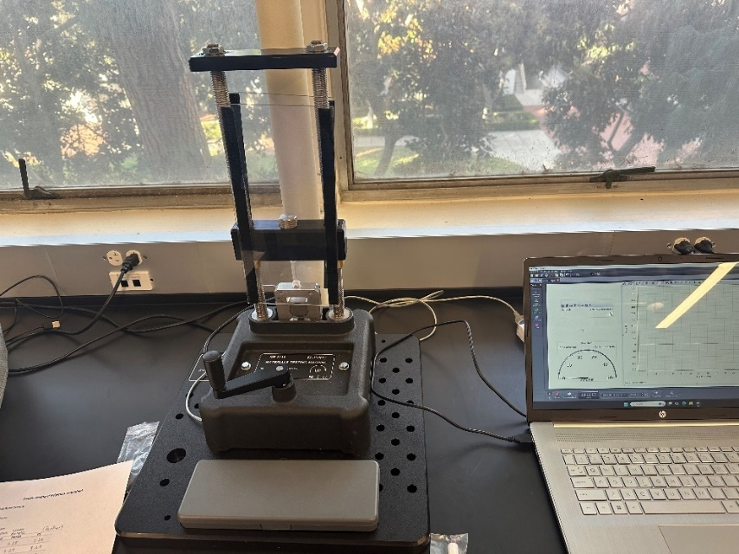
Figure 1 – Load frame plugged into the Pasco Capstone software.

2.2.2 Shear Testing
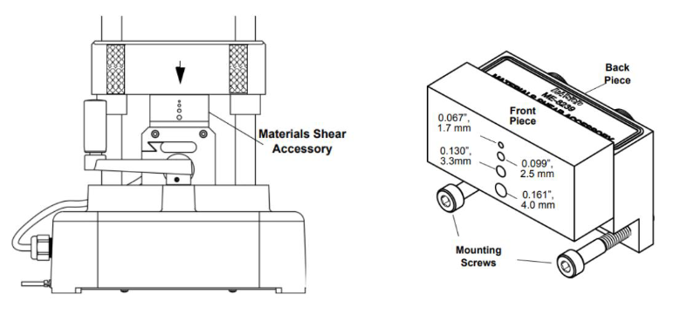
The longer of the two broken tensile samples (dog-bones) was used for shear testing due to the constraints of the machine. The metal adapter for shear testing consisted of two machined metal blocks that could hold the dog-bone sample. The stationary metal block was attached to the load frame, while the moveable block slid vertically to provide the shearing action. The setup was installed with the help of a lab TA. The metal testing system is shown below in Figure 2.
Figure 2 – Machined metal blocks used for shear testing. The shear fixture allows for the adaptation of the load frame to measure shear strength.
The longer end of the selected broken dog-bone was inserted into one of the holes in the metal block. The installation was confirmed by ensuring the free movement of the moveable “shear block” that moved vertically. The crosshead of the load frame was then lowered until it was almost in contact with the top shear block. The safety shields were then installed.
The test began and the data collection was initiated from the laptop by pressing the “record” button. The hand crank was then slowly turned until a small force was registered to confirm the contact between the crosshead and the moveable shear block. A preload of 25-50 N was applied before stopping the data collection and deleting the initial data collection. The “record” button was hit again, and the lab technician smoothly and evenly turned the crank at a rate of 5-10 mm/min until the sample sheared. The process was repeated for the other sample.
2.2.3 Vickers Hardness Test
The last test was conducted on the flat surface of the dog-bone samples. To create a proper micro-indentation the surface was polished using a polishing wheel with 300 grit sandpaper. The samples where then loaded onto the Hardness test setup and was applied a force of 300gf for 10s. To visually observe the proper indent, the microscope used had a built-in micrometer. The micrometer measured both the horizontal and vertical directions of the indent. This process was done on 4 times for each metal sample to record an average diameter number. The experimental setup of the Vickers hardness test is shown below in Figure 3.
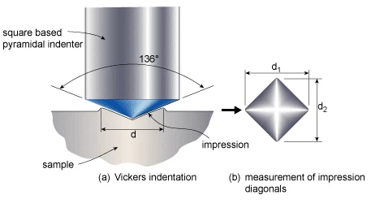
Figure 3 – Illustration of the experimental setup of the Vickers hardness test. [2]

3. Results
3.1 Tensile Testing
Prior to the start of tensile testing, the dimensions of each sample were recorded for the calculations for engineering stress and strain. The length of the dog bone sample section was recorded as $L_{0}=35 [mm]$ for both samples and $d_{0}=3.39 [mm]$ for Brass 360 and $d_{0}=3.30 [mm]$ for aluminum.

On the PASCO Capstone software, the tensile testing for aluminum and brass were conducted as two separate runs. A graph of the raw data was collected and interpolated in Excel. The plot below consists of the tensile testing of brass (blue) and aluminum (orange) where the engineering stress was solved in MPa and plotted against engineering strain. This is shown in figure 4 below.

The stress-strain curve demonstrates the distinct mechanical properties of both brass and aluminum under tensile loading. Aluminum exhibits a steeper initial rise in stress, indicating a higher yield strength than brass. The ultimate tensile strength of aluminum is also greater than brass because it can withstand more engineering stress. Furthermore, aluminum can resist a higher amount of loading before undergoing permanent plastic deformation. Aluminum’s curve indicates lower ductility and a quicker fracture point than brass. Although having a lower yield strength, brass has greater ductility as shown in figure 4. The long flat region of the curve indicates its ability to sustain more strain before its fracture point. Brass can withstand greater elongation before failure and is more resistant to fracture over a larger portion of strain.
Figure 4 – The stress strain curve for Brass 360 and 2024_T3 Aluminum. Brass has a higher engineering stress at yield and ultimate tensile strength.

3.1.1 Linear Elastic Region
To find the yield strength, a plot was created to identify the point where the material transitioned from the elastic to plastic region. This gradual transition from the elastic to plastic region is shown below in Figure 5 with a clearly defined trendline as well as an intersection line. Both graphs for brass and aluminum are showed below to display their mechanical behaviors under stress. The plots highlight distinct yield points and strain hardening characteristics of each material. This measurement is dependent on the strain data collected in the lab. This is where the material begins to encounter plastic deformation, rather than just elastic deformation. The offset is set to 0.2% above the linear portion of the stress-strain curve.

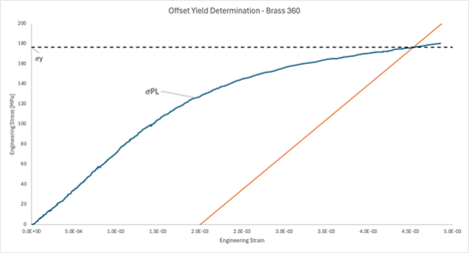
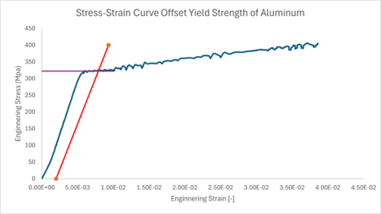
Figure 5 - Yield strength is plotted and calculated using the 0.2% offset rule. [On the right] The red trendline is the offset yield determination line, while the purple line is the intersection line. The stress-strain curve also includes data points that are non-linear
The 0.2% offset yield $σ_{y, 0.02}$ was determined to be 176.5 MPa for brass 360 and 322 MPa for aluminum 2024-T3. As seen in Figure 5, $σ_{y, 0.02}$ is marked by the intersection of the 0.2% offset line (orange), and the stress-strain curve for brass (blue). Furthermore, $σ_{PL}$ is marked as the part of the stress-strain curve that starts to become non-linear.

3.1.2 Offset Yield
Using the data collected from tensile testing, the Elastic Modulus E was determined to be 69.8 GPa for brass 360 and 54.5 GPa for Aluminum 2024-T3. Using a linear trendline for the beginning portion of the stress-strain data set, a slope equation was computed. As seen in Figure 6, the linear elastic region of the stress-strain curve is plotted against a linear trendline. This process was used for both brass and aluminum.

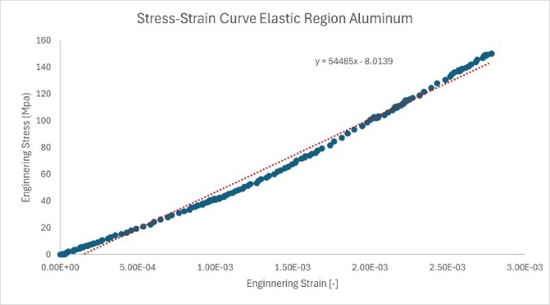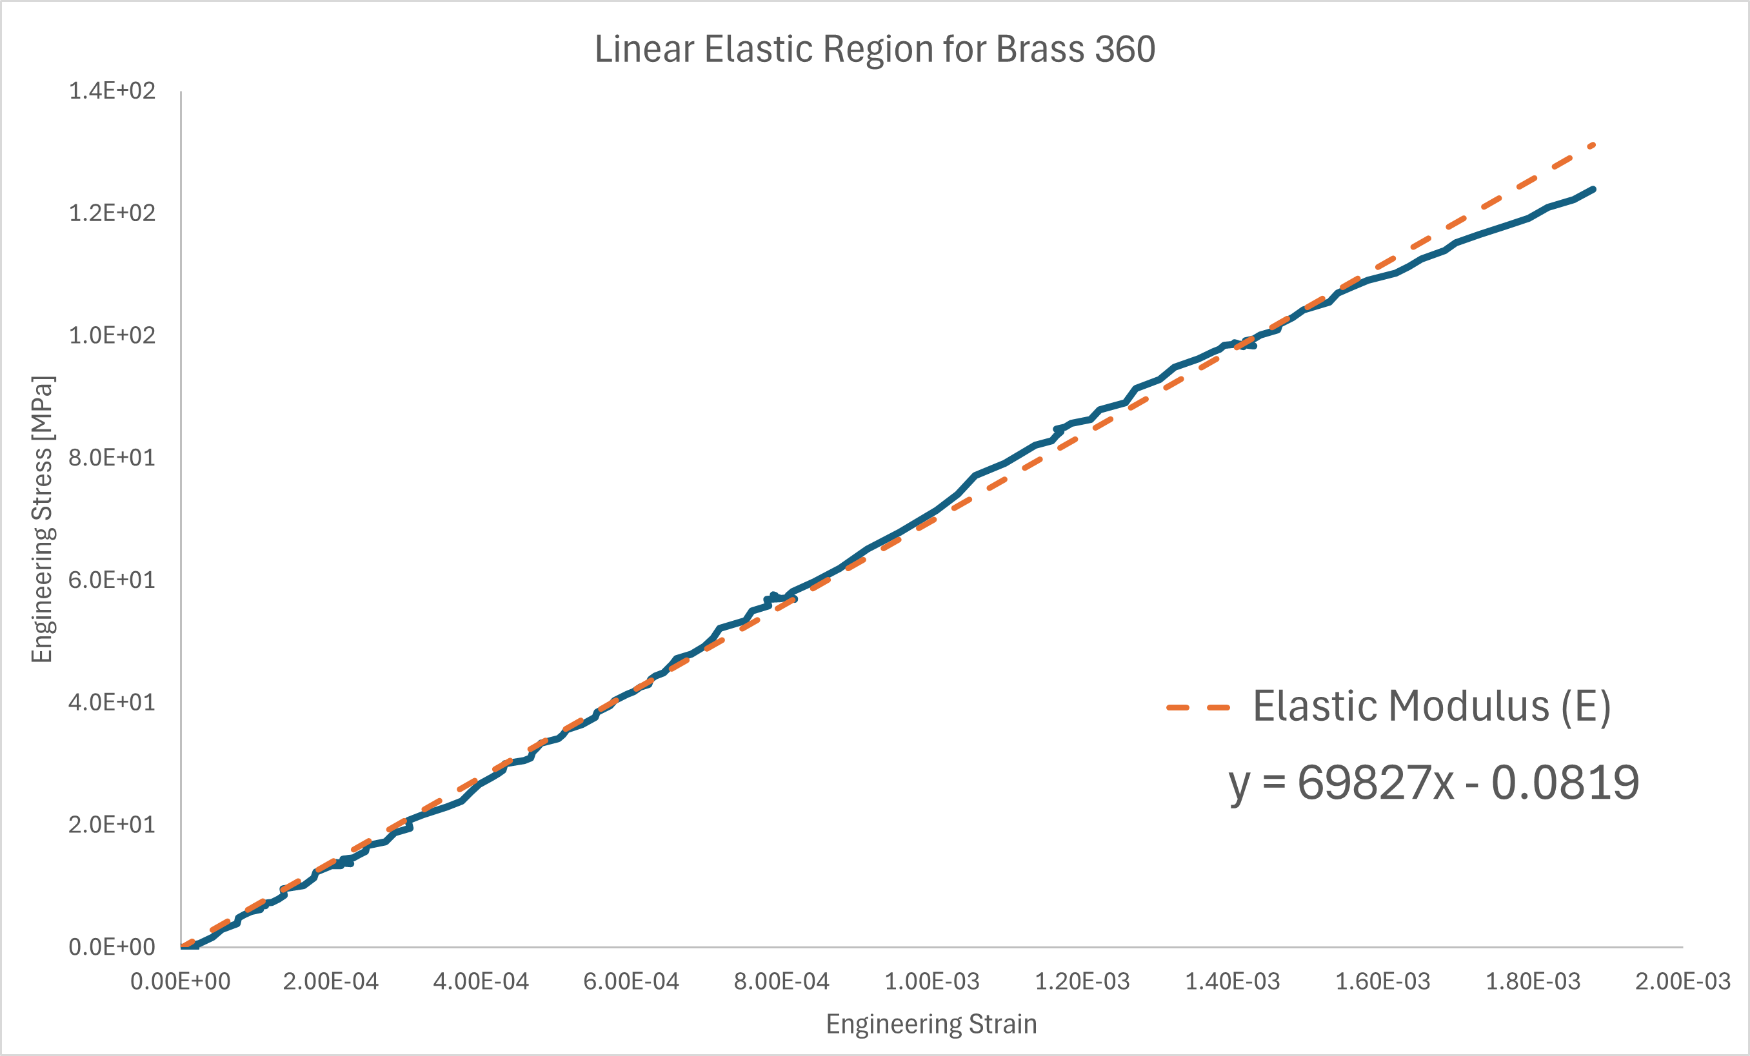
Figure 6 – Plot of linear elastic region of Brass 360 and Aluminum 2024-T3 stress-strain curve. Note the slope of the linear trendline (dashed orange) is equal to the elastic modulus of this region for the material

The key property values for Aluminum 2024-T3 and Brass 360 were compiled in Table 1 below. Overall, aluminum demonstrated a higher tensile strength value of 458.203 MPa compared to the tensile strength of brass, which is 413.81 MPa. Aluminum also had a significantly higher offset yield strength which was about 145.5 MPa greater than that of brass and aluminum had a proportional limit that was 186 MPa greater than that of brass. However, brass had a higher Young’s Modulus and demonstrated greater ductility than aluminum.

Table 1 - The numerical data for Aluminum 2024_T3 and Brass 360. This data table is composed of values from data analysis in Microsoft Excel.
Metal | Young’s Modulus  E [GPa] | Offset Yield Strength  [MPa] | Proportional Limit  [MPa] | Tensile Strength [MPa] | Ductility (%EL) | Work of Fracture [MJ/] | Shear Strength  [MPa] | Ratio
Al 2024-T3 | 54.5 | 322 | 312 | 458.203 | 10.568 | 45.4 | 240.852 | 0.5256
Brass 360 | 69.8 | 176.5 | 126 | 413.81 | 22 | 79.014 | 275.209 | 0.665

3.2 Vickers Hardness Testing
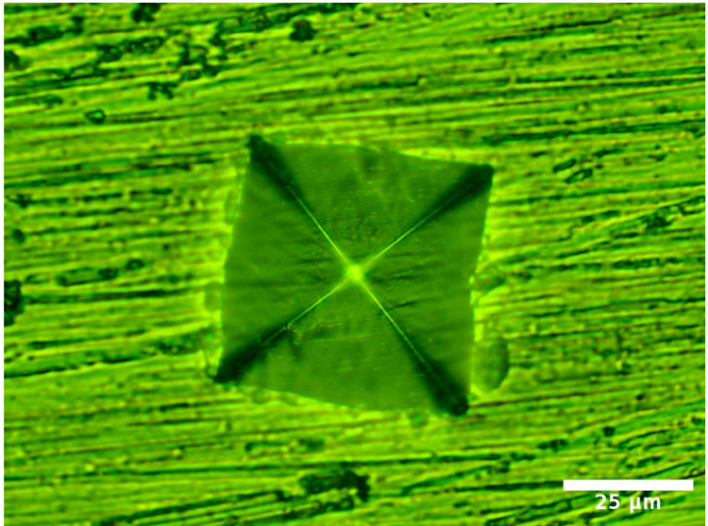
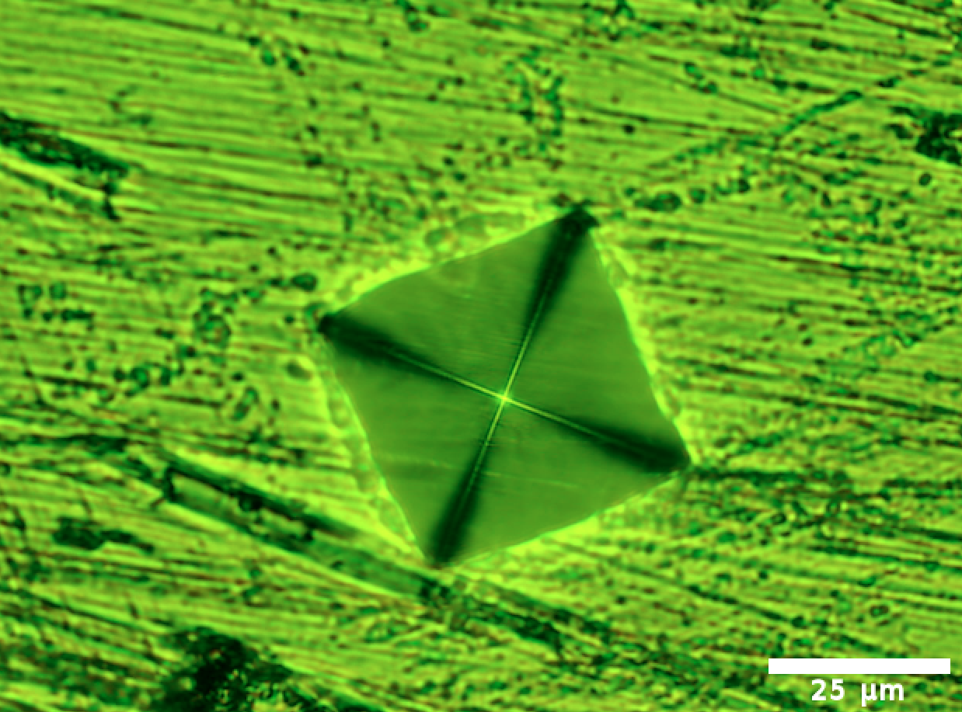
Following the tensile and shear testing, a Vickers Hardness test was conducted on both the brass and aluminum. The expected hardness correlates with the materials’ strength. In the figure below, each indentation was created using 300gf for 10 secs for each sample.

Figure 7 - Vickers Hardness Indent: Brass (Left) and Aluminum (Right)

Images were analyzed using Image J, with a scale bar set to 25$μm$to properly scale to create a better comparison for both samples. Each indent was measured in both the horizontal and vertical direction and then averaged to calculate for the following values on the Table 2 below.

Table 2 - Hardness and Strength calculations for Aluminum and Brass
Metal | Average Diameter | Average Vickers Hardness (HV) | Hardness- H (MPa) | Estimated Yield Strength $σ_{y} (MPa)$
Al 2024-T3 | 66.48 | 126.64 | 1241.96 | 413.99
Brass 360 | 57.48 | 170.08 | 1667.97 | 555.99

Based on the following calculated results, Brass indicates to higher hardness property of 1667.97 MPa whereas aluminum is 1241.64 MPa. This is not only evident in the calculations but also represented through a visual representation shown in figure 7. The indentation for Brass is smaller than the indentation on the Aluminum.

4. Discussion
4.1 Tensile Data Analysis:
Looking closely at the tensile graphs for aluminum and brass, we notice the strength differences between the two metals. The most obvious difference between the two metals is the ductility, with the brass sample having a much longer plastic deformation section than that of aluminum. Looking back at Table 1, we notice that the brass sample has a 22% EL while the aluminum 2024-T3 has only a 10.568% EL. Overall, the brass sample was able to withstand about double the amount of deformation before fracture than aluminum was, shown in the stress-strain curve.

From Table 1, we can also identify the differences between resistance to elastic deformation and the material’s elastic limit. While the brass sample held a higher Young’s Modulus with a value of 69.8 GPa, the aluminum sample showed a higher value for the 0.2% offset yield strength (322 MPa). Figuratively magnifying these values suggests that aluminum would be ruled out before brass when designers wanted an engineering product to be stiffer. Similarly, this data implies that brass could return to its original shape much easier than aluminum could because of the higher 0.2% offset yield strength value, making it a smarter choice for something that would need to bend or absorb a significant amount of energy before failure.

4.2 Shear Data Analysis
The main calculation performed from our shear data was the shear strength for each metal. The shear strength is determined by the maximum shear stress value, which came out to 240.852 MPa for Aluminum 2024-T3 and 275.209 MPa for Brass 360. The brass sample performs slightly better in shear loading, however both values are quite close to each other. This data suggests that greater forces are required to break/reform the atomic bonds in brass.
A common example for the relevance of higher shear strength is present, especially in infrastructure applications, where a material will need to withstand high shear stresses to prevent slippage of atomic bonds and failure of the structure itself. While brass or aluminum may not always be suitable for large-scale infrastructure, this could be an important property to evaluate alongside other mechanical properties for other projects or structures.

4.3 Manufacturer’s vs. Experimental Property Values
A reference for our experimental data can be seen in the comparisons made with the manufacturer’s property values. While most of the mechanical property values are quite similar between the manufacturer and our lab, the ductility numbers are extremely different. While our experiment calculations give us 22% EL for Brass 360 and ≈10.6% EL for 2024-T3 Al, the manufacturer’s ductility values were 11% EL and 14% EL respectively. Although this doesn’t necessarily represent a flaw in our values, it may represent a difference in how we conducted testing compared to the manufacturer. An easy way to stray from the manufacturer’s values could’ve been the difference in strain rate during the tensile test. Pulling at an inconsistent, or consistently slower, rate than the manufacturer’s testing could explain the much larger % EL calculated for our brass sample.

4.4 Hardness Testing Analysis
Aside from tensile and shear testing, Vickers hardness testing was performed to gather additional strength values, as well as confirm and compare expected yield strength values. We see that the Vickers hardness values gathered are inversely proportional to the average diagonal distance of the indents because when calculating Vickers hardness, that distance resides in the denominator. A larger diagonal distance, in turn, means that the material has a lower hardness value. This implies that with the same 300gf load, the indent tool was able to penetrate slightly farther into the aluminum sample. With these hardness values, we can calculate an estimated yield strength for each material.
When comparing this hardness yield strength data to the tensile offset yield strength data, we find that the numbers are not as similar as desired. While the tensile offset yield strength for the aluminum sample is different than the hardness yield strength value by only around 100 MPa, the tensile offset yield strength value for the brass sample is less than the hardness yield strength value by almost 400 MPa.
Interestingly, the manufacturer’s yield strength values for tensile testing were much closer to the experimental tensile yield strength values than the estimated yield strength from hardness testing. This could indicate that determining yield strength from hardness values is not the most accurate way to gather yield data, where tensile testing might be much more reliable.

4.5 Error Analysis
It is important to point out some discrepancies in the stress-strain curves. For instance, the data in the plots look somewhat choppy which could have been caused by not using the tensile tester machine properly. During the lab, it was noted that the constant force applied was not always constant. Hence the wave-like deformations in the stress-strain curve. If a more even force was applied the data would be a lot cleaner.
Due to this variable of uncertainty within tensile and hardness testing, this speaks to the importance of incorporating a factor of safety when selecting a material for a specific task. In the case where an engineer is deciding on a material to withstand an expected, specified load P. A factor of safety of 1.5-2.0 can be applied, note that for critical applications, the factor of safety can be raised. For instance, when choosing between brass 360 and aluminum 2024-T3 and if a 1.5 factor of safety is applied, aluminum should be used if the tensile load is greater than 1,062 N. At 1,062 N, the tensile stress applied exceeds the yield strength of brass when the 1.5 factor of safety is applied. However, if the load exceeds 4,131 N, then the tensile stress exceeds the yield stress of aluminum.

5. Conclusion
In this study, tensile, shear, and hardness testing were conducted on two metal samples: Aluminum 2024-T3 and Brass 360. Using the results from the tensile testing processes, the mechanical properties, such as Young’s Modulus, yield strength, ultimate tensile strength, etc., of the two samples were determined. Through shear testing, we were able to compare the tensile strength of the metal compared to its shear strength, has seen in the ratio of Table 1. Then, using the data collected, we were able to plot the stress-strain curve for both metals, and using the data collected from Vickers Hardness testing, we were able to calculate the level of hardness and yield strength of each metal.
As mentioned previously, the objective of this lab was to accurately test each metal through these three testing modes and make comparisons between our calculated values and with the manufacturer’s specifications. In the discussion section, it was noted that the difference in values for ductility compared to the specifications can be attributed to different testing modes used by the manufacturer. In our testing, were limited to the apparatus that was readily available to us and it is possible that the manufacturer uses a higher precision, non-destructive testing to determine the mechanical properties of their brass and aluminum samples. Overall, the objectives of this experiment were met since we were able to conduct tensile, shear, and hardness testing on the aluminum and brass samples and determine their mechanical properties to a degree of accuracy with the equipment given.
The testing and analysis conducted within this experiment also speak to real-world engineering practices and procedures. Based on the data and analysis performed on both metal samples, the aluminum 2024-T3 sample would be better suited for structural applications due to its resistance to deformation. Compared to the brass, the aluminum sample was able to endure higher loads with minimal strain and maintained a higher yield strength. On the other hand, brass is more suitable for complex part manufacturing due to its ductility. Despite not being able to withstand higher loads, the ductility of brass would make it a suitable metal for bending while minimizing the risk of failure. The testing and data analysis within this lab provided insight into the mechanical properties of aluminum 2024-T3 and brass 360 and allowed for discussion of the importance of each mechanical property. By comparing the properties of each metal, property trade-offs, such as stiffness and ductility, can be analyzed between any two metals and are something taken into consideration when engineers choose a material within their design process.

6. References
Aluminum (2024-T3) and brass (360) data sheets, Pasco Scientific
Materials Testing Machine (ME-8236) Instruction Manual, Pasco Scientific, 012-
13762D
MASC 310L, Lab Manual, Fall 2024
External Sources:
[1] Saba, N., Jawaid, M., and Sultan, M. T. H., “An Overview of Mechanical and Physical Testing of Composite Materials,” Elsevier eBooks, 2018, pp. 1–12. https://doi.org/10.1016/b978-0-08-102292-4.00001-1
[2] Vickers hardness testing. Hardness Tester. (2022, July 8). https://www.hardnessgauge.com/testing-types/vickers-hardness-testing/
[3] Weiler, W. and Federal Institute of Physics and Technology, “The Relationship between Vickers Hardness and Universal Hardness,” June 2019, pp. 13–16.

